Лабораторная работа №3

Графическое представление логической (переключательной) функции как зависимости выходного сигнала от входных с помощью стандартных элементов.

1. **Цель работы**

* Научиться графически предоставлять логическую функцию
* Научиться находить минимальную дизъюнктивную нормальную форму и минимальную конъюнктивную форму по заданной переключательной схеме.

1. **Оборудование:** Ms Excel, Word, ПК
2. **Выполнение работы. Вариант 5**

№ 1.

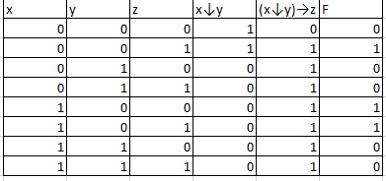

СДНФ: (Не(x) & Не(y) & z) ИЛИ (x & Не(y) & Не(z)) ИЛИ (x & Не(y) & z)

МДНФ: (x & Не(y)) ИЛИ (Не(y) & z)

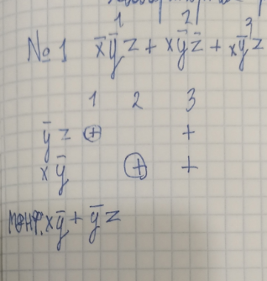

|  |  |  |  |  |  |  |  |  |  |
| --- | --- | --- | --- | --- | --- | --- | --- | --- | --- |
| X | 1 |  |  |  |  |  |  |  |  |
|  |  |  |  |  |  |  |  |  |  |
|  |  |  |  |  |  |  |  |  |  |
|  |  |  |  |  |  |  |  |  |  |
|  |  |  |  |  |  |  |  |  |  |
| Y | 0 |  | НЕ(Y) | 1 |  |  | X * НЕ(Y) | 1 |  |
|  |  |  |  |  |  |  |  |  |  |
|  |  |  |  |  |  |  |  |  |  |
|  |  |  |  |  |  |  |  |  |  |
|  |  |  |  |  |  |  |  |  |  |
| Z | 1 |  |  | Не(Y) * Z | 1 |  |  | X * НЕ(Y)+ Не(Y) * Z | 1 |

№ 2.

СДНФ: (Не(x) & y & z) ИЛИ (x & y & z)

СНКФ: (x ИЛИ y ИЛИ z) & (x ИЛИ y ИЛИ Не(z)) & (x ИЛИ Не(y) ИЛИ z) & (Не(x) ИЛИ y ИЛИ z) & (Не(x) ИЛИ y ИЛИ Не(z)) & (Не(x) ИЛИ Не(y) ИЛИ z)

МДНФ: yz

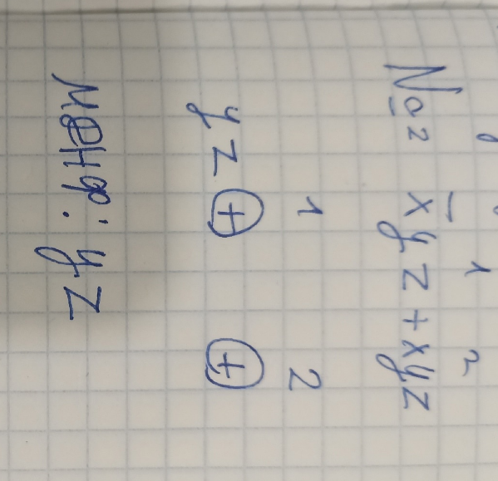

|  |  |  |  |  |  |
| --- | --- | --- | --- | --- | --- |
| Y | 1 |  |  |  |  |
|  |  |  |  |  |  |
|  |  |  |  |  |  |
|  |  |  |  |  |  |
|  |  |  |  |  |  |
| Z | 1 |  |  | Y*Z | 1 |

№ 4.

Не(Не(x ИЛИ Не(y))) & (Не(y) ИЛИ z)

|  |  |  |  |  |
| --- | --- | --- | --- | --- |
| x | y | z | Не(y) | F |
| 0 | 0 | 0 | 1 | 1 |
| 0 | 0 | 1 | 1 | 1 |
| 0 | 1 | 0 | 0 | 0 |
| 0 | 1 | 1 | 0 | 0 |
| 1 | 0 | 0 | 1 | 1 |
| 1 | 0 | 1 | 1 | 1 |
| 1 | 1 | 0 | 0 | 0 |
| 1 | 1 | 1 | 0 | 1 |

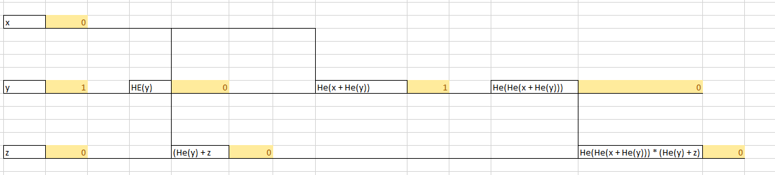

№ 5

|  |  |  |  |  |  |  |  |  |  |  |  |  |  |  |  |  |  |  |  |  |  |
| --- | --- | --- | --- | --- | --- | --- | --- | --- | --- | --- | --- | --- | --- | --- | --- | --- | --- | --- | --- | --- | --- |
|  |  | |  |  | |  |  | |  | |  |  | |  |  |  |  |  |  |  |  |
|  | A | | 1 |  | |  |  | |  | |  |  | |  |  |  |  |  |  |  |  |
|  |  | |  |  | |  |  | |  | |  |  | |  |  |  |  |  |  |  |  |
|  |  | |  |  | |  |  | |  | |  |  | |  |  |  |  |  |  |  |  |
|  |  | |  |  | |  |  | |  | |  |  | |  |  |  |  |  |  |  |  |
|  |  | |  |  | |  |  | |  | |  |  | |  |  |  |  |  |  |  |  |
|  | B | | 0 |  | |  | A+B | | 1 | |  |  | |  |  |  |  |  |  |  |  |
|  |  | |  |  | |  |  | |  | |  |  | |  |  |  |  |  |  |  |  |
|  |  | |  |  | |  |  | |  | |  |  | |  |  |  |  |  |  |  |  |
|  |  | |  |  | |  |  | |  | |  |  | |  |  |  |  |  |  |  |  |
|  |  | |  |  | |  |  | |  | |  |  | |  |  |  |  |  |  |  |  |
|  | C | | 0 |  | |  | НЕ(С) | | 1 | |  |  | | НЕ(С) * (A+B) | 1 |  |  | НЕ(С) * (A+B) + C | 1 |  |  |
|  |  | |  |  | |  |  | |  | |  |  | |  |  |  |  |  |  |  |  |
|  |  | |  |  | |  |  | |  | |  |  | |  |  |  |  |  |  |  |  |
|  |  | |  |  | |  |  | |  | |  |  | |  |  |  |  |  |  |  |  |
|  |  | |  |  | |  |  | |  | |  |  | |  |  |  |  |  |  |  |  |
|  |  | |  |  | |  |  | |  | |  |  | |  |  |  |  |  |  |  |  |
|  |  | |  |  | |  |  | |  | |  |  | |  |  |  |  |  |  |  |  |
|  |  | |  |  | |  |  | |  | |  |  | |  |  |  |  |  |  |  |  |
| A | | B | | | C | | | НЕ(С) | | F | | |
| 0 | | 0 | | | 0 | | | 1 | | 0 | | |
| 0 | | 0 | | | 1 | | | 0 | | 1 | | |
| 0 | | 1 | | | 0 | | | 1 | | 1 | | |
| 0 | | 1 | | | 1 | | | 0 | | 1 | | |
| 1 | | 0 | | | 0 | | | 1 | | 1 | | |
| 1 | | 0 | | | 1 | | | 0 | | 1 | | |
| 1 | | 1 | | | 0 | | | 1 | | 1 | | |
| 1 | | 1 | | | 1 | | | 0 | | 1 | | |

**Вывод:**

Освоены навыки:

* графически предоставлять логическую функцию
* находить минимальную дизъюнктивную нормальную форму и минимальную конъюнктивную форму по заданной переключательной схеме.